Installation Manual for Crystal Silicon Photovoltaic Modules (IEC)
1 Range
This installation manual specifies the installation and maintenance requirements of crystal silicon photovoltaic modules (hereinafter referred to as "components") produced by Jiangsu Focus New Energy Technology Co., Ltd.
This installation manual is suitable for the installation and maintenance of our conventional components (hereinafter referred to as "components" refer to conventional components), to help customers correctly install photovoltaic power generation system, so as to enable the design system to play its potential. This installation manual is not suitable for installation of double glass components.
2 Introduction to Installation Manual
2.1 Summary
First of all, thank you very much for choosing to use the crystal silicon photovoltaic module of Jiangsu Focus New Energy Technology Co., Ltd. This manual contains important electrical and mechanical installation information. For proper installation and stable power output, please read and understand all installation instructions in the manual carefully before installing and maintaining components. Keep this manual properly for future reference in component maintenance or sale processing.
This manual is applicable to our series of conventional components as follows:
Single crystal conventional components: 72 version series, 60 version series, 54 version series, 96 version series; Polycrystalline conventional components: 72 version series, 60 version series, 54 version series, 96 version series.
This Installation Manual has no meaning of any warranty, express or implied. There are no compensation schemes for loss, damage or other costs incurred or related to the installation, operation, use or maintenance of components.
If you have any questions, please contact our sales staff or customer service staff for further explanation.
2.2 Applicable Products
Component installation shall comply with all safety precautions and local relevant laws and regulations in this manual, and shall be installed and maintained by qualified professionals who have professional knowledge and are familiar with the mechanical and electrical requirements of the system. The mechanical and electrical installation of components shall be in accordance with relevant laws and regulations, including electrical law, building law and electrical connection requirements. These regulations vary with the location of installation, such as building roof installation, water surface installation, vehicle applications, etc. Requirements may also vary depending on the system voltage, DC or AC used. Specific clauses should be based on local laws and regulations.

3 Product Information
3.1 Component Profile Structure and Component Description
3.2 Coding Rules for Conventional Component Types
XXX X - XX X - XXX
Part1: Three letters, representing the company abbreviated as FKS (FKS, the first letter of Chinese Pinyin).
Part2: 1-digit number, representing the batteries, such as: 6 for 156 batteries, 5 for 125 batteries.
Part3: 1 bit character, using fixed characters: -.
Part 4: Two digits, representing the number of batteries in the module.
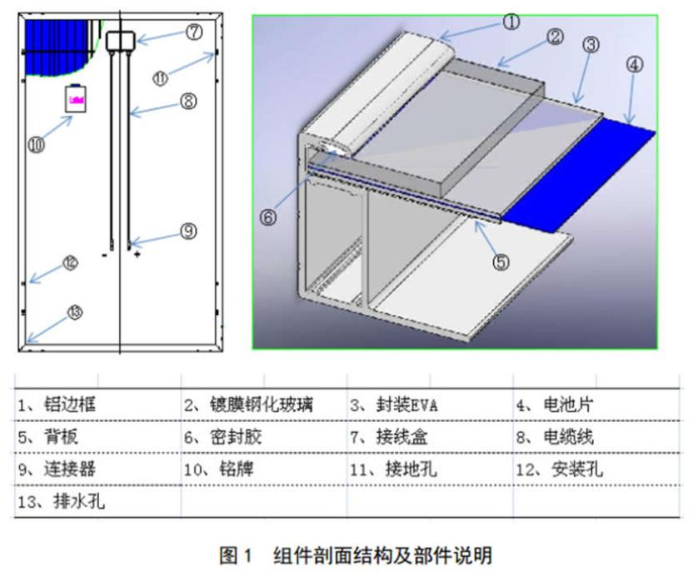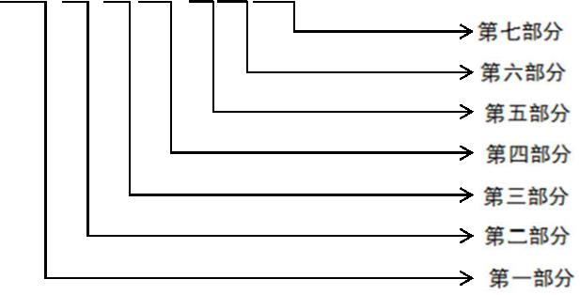
Part 5: 1-bit letter, representing the type of silicon material, such as polycrystalline P, single crystal M.
Part 6: 1-bit character, using fixed characters: -.
Example 1: Module model FKS6-72P-320, which indicates that Focus manufactures modules with 320W power, polycrystalline cells and 72 batteries.
a）Name plate: Describes product name, module model, rated power, rated voltage, rated current, open circuit voltage, short circuit current, maximum system voltage, module size and weight under standard test conditions.
b）Current grading label: Each component has a current grading label on the long frame, and the components are graded according to the best working current value (Im) of the component. When installing, the best operation is to install the components of the same current transmission in a group of strings, which can avoid power loss caused by mismatch effect.
3.4 Electrical performance parameters of components
The electrical performance parameters of the module are measured under the standard test conditions (irradiance of 1000W/m, AM1.5 spectrum, ambient temperature of 25 C), and the uncertainty of the test is <3%. The maximum system voltage of the module is 1000V. Electrical performance parameters are specified in component nameplate or component technical specifications.
4 install
4.1 General Safety Principles
4.1.1 Our component design conforms to IEC 61215 and IEC 61730 standards. Its application level conforms to Class A. Components can be used in systems larger than 50V or 240W DC which may be contacted by the public. The security level of components is Class II, and the fire protection level is Class C.

Part 7: Three digits, representing the maximum power of components under standard test conditions, such as: 260, representing 260W power of components; when less than three digits, the first digit is supplemented by 0.
Example 2: Module model FKS6-72M-320, which indicates that Focus manufactures modules with 320W power, single crystal batteries and 72 batteries.
3.3 Component Label Information
Each component has three labels, which provide the following information:
c）Bar code: Each component has a unique bar code, each bar code has 18 letters and numbers. The bar code is permanently encapsulated in the inner part of the component, which can be clearly seen from the upper right corner of the front of the component. Bar numbers can be used to trace the relevant information of component production process.

4.1.2 When assemblies are installed, they should abide by the laws and regulations clearly stipulated by the relevant regions and countries where they are installed. If necessary, they should first obtain the required certificates such as building permits.
4.1.3 Installation of components shall be carried out by qualified professionals who have professional skills and knowledge and are familiar with the mechanical and electrical requirements of the system.
The risk of injury during installation, including electric shock, should be known in advance.
4.1.4 Components are used in outdoor environments such as ground, roof, vehicle or ship. Reasonable design of support structure is the responsibility of the system designer or installer. When applying to roof installation, it is necessary to consider the overall fire protection level of the final structure and the overall maintenance in the later period. Roof systems can only be installed on roofs that have been evaluated by construction experts and have formal and complete structural analysis results.
4.1.6 For your safety, please do not install and handle components in damp and unfavorable environments, including but not limited to strong winds, gusts, sand roofs, damp environments.
4.2 Electrical Performance Safety
4.2.1 When the components are exposed to sunlight or other light sources, there is DC current generated in the components, and the electrical part of the components may be exposed to electric shock hazard.
4.2.2 In order to avoid the danger of arc and electric shock, do not disconnect the electrical connection without load, keep the connector dry and clean, and ensure that the components are in good working condition. Do not insert other metal objects into connectors or make electrical connections in any other way.
4.2.3 Do not brush paint or other adhesives on the surface of components. Do not wipe components with corrosive chemicals.

4.2.4 Do not focus sunlight on components with mirrors or lenses. Do not expose the back of components directly to sunlight for long periods of time.
4.2.5 Please do not change the wiring of bypass diodes and do not disassemble components.

4.2.6 Do not contact components in a humid state unless cleaning components requires cleaning components in accordance with the manual requirements.

4.1.5 For your safety, please do not install components without safety precautions.

4.3 Safety of handling
4.3.1 Before reaching the installation site, please do not open the packing box. Please put the packing box in a ventilated and dry environment.

4.3.2 Refer to the Focus Packaging Box Unpacking Manual for component unpacking. In all handling processes, make sure that the component is not subjected to major vibration, the component falls to the ground or the object falls on the component, because it will damage the battery in the component or component. Particular care should be taken not to collide, scratch or squeeze into the back of the assembly. Do not let children and unauthorized personnel carry components, improper handling and placement may lead to broken glass or loss of electrical performance of components, loss of the value of components.
4.4.1 Comply with the safety rules applicable to all installation parts. For example, cables and cables, connectors, charging controllers, inverters, batteries and so on, only equipment, connectors, wires and brackets matching the solar power system can be used. If the battery is used in photovoltaic system, the battery manufacturer's opinion should be followed in the configuration of components. Components of the same size and size can be connected in series.
4.4.2 Do not install or operate components in wet or windy conditions, and the junction box cover should be closed.
4.4.3 The glass of the component has the function of protecting the component, and unreasonable operation will cause the glass to break. Damaged components are in danger of electric shock and fire. Such components can not be repaired or repaired and should be replaced immediately.
4.4.4 When the sun shines on the front of the module, the module generates electricity and the DC voltage may exceed 30V. In case of direct contact with 30V or higher voltage, it should be avoided.
4.4.5 In order to reduce the risk of electric shock or combustion, the components can be installed with opaque materials covering the surface of the components. Installation of component arrays must be carried out with isolating solar devices. When installing or repairing photovoltaic systems, do not wear metal rings, watches, earrings and other metal accessories. It is forbidden to touch directly with the electrical parts of the components by hand. Insulating tools should be used for electrical connection and keep the tools dry.
4.4.6 The triangular hole on the back edge of the assembly is a drainage hole. Be careful not to be blocked.

4.3.3 When handling and installing components, they should be handled lightly. In any case, lifting components by lifting junction boxes or cables is prohibited. Two or more people must hold the edges of components with both hands.
4.3.4 It is forbidden to step on, stand on or sit on the components, which will damage the components and risk causing harm to people.

4.3.5 Do not place any heavy objects on the front and back of the component, and do not place the component on the sharp surface of the object.
4.4 Installation Safety

4.4.7 nameplate indicates that the maximum system voltage of the component is 1000V. During the installation of the photovoltaic system, the voltage generated by the components connected in series shall not exceed the maximum system voltage.

4.4.8 When interconnecting components, it is necessary to ensure that the connecting cable is fixed on the support frame of the installation component to limit the swing amplitude of the cable relaxation part.

4.4.9 Comply with the minimum allowable bending radius of the cable (recommended not less than 43mm).

4.4.10 Catheters must be used to protect cables where animals and children can reach them.

4.4.11 Use connectors designed specifically for photovoltaic systems. Use tools recommended or specified by the manufacturer when assembling connectors. For connectors suitable for solar photovoltaic systems, please contact local suppliers. It is strictly forbidden that connectors of different manufactures and models be interpolated.

4.4.12 When the module is connected with the inverter, or the battery, or the shunt box, pay attention to the correct polarity, so as to avoid the damage of the internal bypass diode caused by the polarity error.

4.4.13 No drilling is allowed on the assembly frame, which may reduce the load capacity of the frame and cause the frame to corrode.

4.4.14 Do not scratch the anodic oxide layer on the aluminium alloy frame surface. In addition to grounding connections, scratches may cause frame corrosion and affect mechanical load capacity.

4.4.15 components can not be used to replace roof and wall materials, and partial substitution is not allowed.

4.4.16 No parts (including nameplates) of components provided by Jiangsu Focus New Energy Technology Co., Ltd. can be removed without authorization.

5 Installation Conditions
5.1 Working Environment

The operation of our components shall meet the following environmental conditions:

5.1.1 Recommended Working Environment Temperature: -20 to 45 degrees Celsius

5.1.2 Module Limit Working Environment Temperature: - 40 C to 85 C

5.1.3 Humidity: below 85% RH

5.1.4 Mechanical Load Bearing Capacity: 2400Pa Wind Pressure and 5400Pa Snow Pressure (Only Module Types Involved in this Manual)
Note: The mechanical loads of components are based on the installation method and location. When calculating the mechanical loads, professional installers calculate the mechanical loads according to the design requirements of the system.

5.2 Installation Location

5.2.1 In most applications of photovoltaic modules, the modules should be installed in the location where the maximum exposure of sunlight can be received locally throughout the year. In the northern hemisphere, the component is usually selected for installation in the south; in the southern hemisphere, the component is usually selected for installation in the north.

5.2.2 When choosing the installation location of the module, the position where the sunlight can be fully illuminated should be selected. Partial or total occlusion (obstacles such as trees, buildings, clothing, tools, packaging materials, etc.) should be avoided on the surface of the module, because these objects will form shadows on the module, which will cause solar photovoltaic system. Loss of output power.

5.2.3 Components should be installed in a well-ventilated position to ensure adequate air circulation on the back and side of the components, so as to facilitate the timely distribution of heat generated when the components are working.

5.2.4 modules can not be used in hail, snow, sand, smoke, air pollution, soot, flammable gas, near open fire, strong corrosive substances (such as salt, salt spray, salt water, acid rain) and other excessive and harsh environments, because this will affect the safety and performance of components. If the installation environment is special, such as seashore, farm, high humidity or sandy environment, please consult local distributors for professional support and confirmation.

5.2.5 Components shall be installed in suitable buildings or other places suitable for assemblies (e.g. ground, garage, building exterior walls, roof).

5.2.6 If components are installed in places where frequent lightning activities occur, lightning protection devices must be installed on components.

5.2.7 Do not install components where there is water immersion, sprinkler or sprinkler.

5.2.8 Components shall not be subjected to wind or snow pressure greater than the maximum allowable load after installation.
5.3.1 Component Inclination: The angle between the surface and the horizontal surface of the component. When the component is facing the sunlight, the component achieves the maximum power output, as shown in Figure 2.

5.3.2 Each component in series with the same array must ensure the same direction and angle. Different installation directions and angles will lead to the difference of total solar radiation absorbed by components, resulting in the loss of output power, thus reducing the operational efficiency of the system.

5.3.3 When the sunlight shines directly on the module, the maximum power is generated. Winter power output of the module should be considered when choosing the best installation angle.

5.3.4 In order to facilitate the cleaning of the components and the dust on the surface of the components is easily washed away by rain when it rains, for detailed installation angle, please follow the advice given by experienced photovoltaic module installers.

5.3 Choice of Inclination Angle

6 Mechanical Installation

All the installation methods introduced here are for reference only. Our company is not responsible for providing the relevant installation parts and components installation services.

6.1 Conventional Requirements

6.1.1 Ensure that the assembly mode and bracket system are strong enough, and that the whole square system composed of components must be able to withstand the preset mechanical load pressure. This is the guarantee that the bracket installer must provide. The bracket must be tested by a third-party testing institution with static mechanical analysis capability and must be adopted internationally. Standards or national standards.

6.1.2 Component mounting bracket must be made of anti-corrosion, anti-rust and anti-ultraviolet materials.

6.1.3 Components require to be firmly mounted on the system bracket.

6.1.4 It is forbidden to drill additional mounting holes in the assembly frame and glass, otherwise the assembly quality assurance will fail.

6.1.5 component bracket structure will have thermal expansion and contraction effect. In order to avoid affecting the performance and use of components, it is recommended that the minimum distance between the two components is 10 mm. However, in order to ensure good ventilation and reduce load, the installation distance between the two components is recommended to be 30 mm.

6.1.6 In areas with large snow cover in winter, choose a higher mounting bracket, so that the lowest point of the components will not be covered by snow for a long time. In addition, the lowest point of the components is high enough to avoid being covered by plants or trees.

6.1.7 The support surface of the mounting bracket must be flat, non-twisted and deformed, and there should be no dislocation between the upper and lower brackets.

6.1.8 components can not lead to electrochemical corrosion between the aluminium frame of the components and different metals.
6.2 Three Application Places for Component Installation
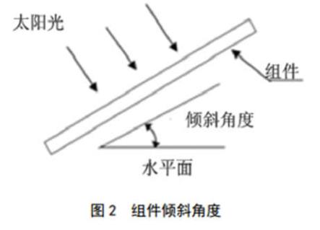
6.2.1 Roof Installation

6.2.1.1 It is necessary to provide a special support frame for roof installation. When assemblies are installed on roofs or buildings, ensure that they are securely fixed and will not be damaged or dropped by strong winds or heavy snow. When installing roofs, the building codes used should be checked to ensure that the buildings and structures installed by the components have sufficient bearing capacity and sealing. The roofs penetrated by the fixed components should be sealed to prevent rainwater leakage.

6.2.1.2 In order to be suitable for operation, reduce water vapor condensation, promote ventilation and heat dissipation of components, components should be parallel to the surface of building walls or roofs as far as possible, and ensure that the surface distance between components and walls or roofs is at least 115mm, so that the air flow on the back of components can facilitate heat dissipation and prevent cable parts. Damage. When installing stacked components, it should be ensured that components are installed on the fire-proof roof. The fire-proof level of components is C, which is suitable for installing on the roof above the fire-proof level A.

6.2.1.3 For roof systems with large snowfall or snow cover records in the installation area, customers should reinforce the bottom component frame of the whole system to ensure that the bottom component frame is not damaged by snow pushing from top to bottom, and that the components are damaged by snow melting and freezing in daytime. It is suggested that the reinforced support structure shown in Figure 3 should be adopted.
6.2.2 Pillar Installation

When assemblies are installed on the pillars, the pillars and assemblies mounting brackets that can withstand the expected local wind force are selected. The supporting rods must have a solid foundation.

6.2.3 Ground Installation

When installing on the ground, choose the appropriate installation height to prevent the lower half of the assembly from being covered by snow for a long time in winter. The appropriate height of the bracket should be selected for installation, and the components should not be laid directly on the ground obliquely. In addition, ensure that the lowest part of the assembly is more than 900 mm to avoid being blown away by plants or trees, and to avoid being blown by sand and stones to damage the assembly or to be splashed by rain to cover the surface of the assembly.

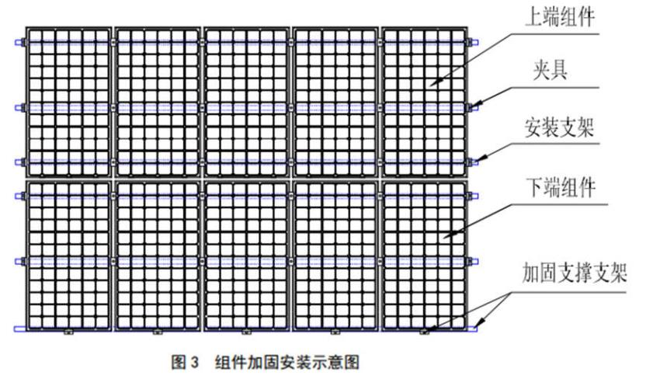
6.3 Component Installation in Two Fixed Ways

6.3.1 General Provisions

A) Components can be mounted directly by bolting the mounting holes or clamping the components with pressure fixtures. Component installation must be carried out in accordance with the following methods, otherwise the quality assurance will fail.

B) Our components have met the requirements of IEC standard for mechanical loads. When installing, fix the component on the bracket by screw through 4 or 6 symmetrical mounting holes on the inside of the frame or by pressure fixture. Our component can withstand 2400 Pa wind pressure and 5400 Pa snow pressure (only the component type mentioned in this manual). It is recommended that the system designer or installer carry out load calculation.

C) Brackets and other required materials (such as bolts, etc.) should be made of durable, anti-rust and anti-ultraviolet materials.

6.3.2 Screw Installation

6.3.2.1 The anti-corrosion M8 bolts are fixed through the mounting holes on the assembly frame. Each component needs to be fixed on four or six mounting holes, as shown in the schematic diagram of the mounting holes of the fixed component in Table 2. If the installation needs to be strengthened, it is recommended to use 6.3.3 fixture installation method.

6.3.2.2 When fixing with M8 bolts, spring gaskets and flat gaskets must be added to four or six symmetrical installation holes. See the bolt fixing schematic in Table 2. The recommended torque for screw tightening is 16N M. The recommended accessories are shown in Table 2.
6.3.3 Fixture Installation
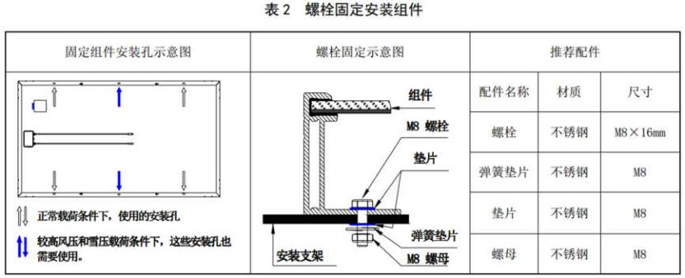
6.3.3.1 Fixed the assembly on the mounting bracket with a certain number of fixtures. Our company recommends that fixtures be clamped on the long frame of the assembly. The area of A plane of the frame of each fixture clamping component is not less than 400 mm (length of fixture: > 50 mm, width range of contact between fixture and A plane of the frame: 8-10 mm).

6.3.3.2 When installing fixture, do not touch the front glass, scratch the aluminium frame or cause its deformation during installation. At the same time, fixture can not affect the normal work of components. When installing fixture, ensure that drainage holes and grounding holes are not blocked.

6.3.3.3 Each module needs at least four fixtures to be fixed and at least two fixtures for each long frame. According to the local application conditions (wind load and snow load), additional fixtures may be needed to ensure that solar photovoltaic modules and systems bear the corresponding loads. Fixtures under the following conditions are recommended. (as shown in Figure 4), or Approved by component system installer.
Fig. 4 Assembly fixture installation method
6.3.3.4 When clamping the fixture on the frame of the component, spring washer, flat gasket and bolt should be used to fix the component on the mounting frame. Attention should be paid to the symmetrical position of both ends. It is recommended that M8 bolts and matching bolts be used to fix the fixture. The torque of screw tightening is 8N·m.
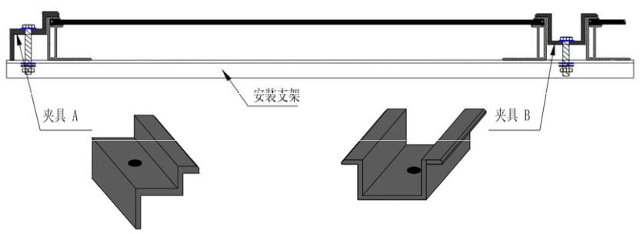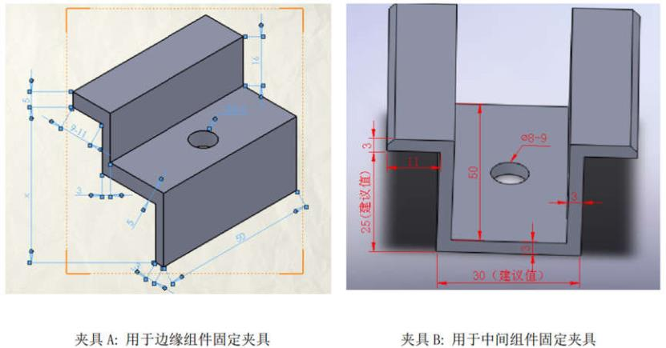
6.3.3.5 If there is snow or snow pressure and wind pressure in the installation area, it is suggested that customers use 5400Pa to strengthen the installation to clamp the fixed components (as shown in Table 3) in order to improve the static snow pressure and dynamic wind pressure on the front and back of the components and improve the compressive capacity of the system.
6.3.3.6 If customers have special clamping and installation schemes that are not included in this manual, please consult local distributors for professional support.

7 Electrical Installation

7.1 Electrical Performance

7.1.1 Under normal outdoor conditions, the current and voltage generated by the module will be different from those measured under standard test conditions in the module nameplate of our company. Therefore, when determining the parameters related to the rated voltage, conductor capacity, fuse capacity, controller capacity and component power output in photovoltaic power generation system, we should The corresponding short circuit current and open circuit voltage are designed and installed at 125% value.
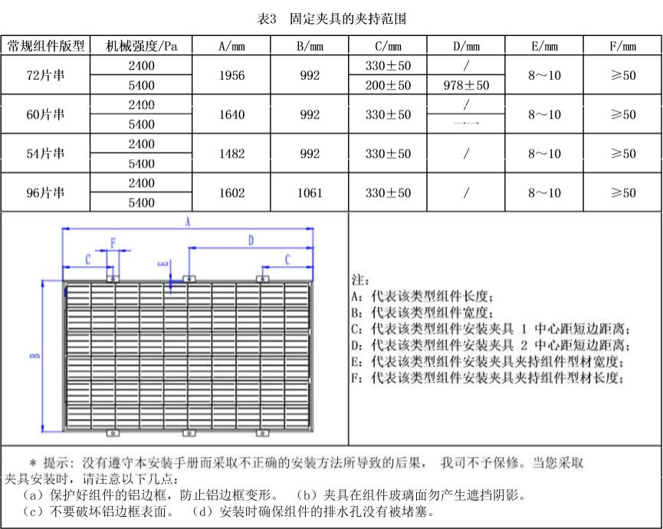
7.1.2 Make the best use of the same components in the same photovoltaic system. If the components are connected in series, the total voltage is equal to the total voltage of each component, and the voltage of each series can not exceed the maximum voltage of the system (the maximum system voltage of the components in our company is 1000V). The maximum number of series components can be calculated according to the requirements of relevant regulations. The open-circuit voltage under the local minimum temperature can not exceed the maximum system voltage and other DC electrical components required by the components. The system voltage is calculated using the following formula.
system voltage =N×Voc×[1＋λv （Tmin-25℃） ]
oc
In the formula：
N——Number of components in series
Voc—— Open-circuit voltage value of components under STC (see component nameplate)
λv ——Open-circuit voltage-temperature coefficient of components (see technical specifications for components)
oc
Tmin——Minimum Annual Temperature for Component Installation Location (minus 20 degrees Tmin = -20)
7.1.3 When a high current system needs to be installed, several photovoltaic modules can be connected in parallel. The total current is equal to the total current of each module. The maximum number of components is N= Imax (maximum fuse current)/ Isc.

7.1.4 If there may be a reverse current passing through the component that exceeds the maximum fuse current of the component, an overcurrent protection device of the same specification must be used to protect the component. If the number of parallel connection is greater than or equal to 2 series, there must be an overcurrent protection device on each series of components.

7.1.5 When installing components, the terminal box is installed upward to avoid being rained.

7.1.6 Do not install in rainy weather. Moisture will lead to failure of insulation protection and prone to safety accidents.

7.2 Cable and Wiring

7.2.1 Components use junction boxes with IP67 or above protection level. The junction boxes have connected cables and connectors. Each component's junction box is equipped with two separate wires, one positive pole and one negative pole. By inserting the positive interface of one component into the outlet of the negative conductor of the adjacent component, the two components can be connected in series.

7.2.2 During installation, it is forbidden to clean connectors, junction boxes, cables and other components with lubricants or alkanes.

7.2.3 The cross-sectional area of the selected cable and the capacity of the connector must meet the maximum short-circuit current of the component (for a single component, the cross-sectional area of the cable is 4 square millimeters, and the temperature range of the cable is - 40 ~90 C).

7.2.4 When the cable is fixed on the bracket, it is necessary to avoid mechanical damage to the cable or components. The cable is fixed on the bracket by special designed light-resistant tie and wire clip. The cable is light-resistant and waterproof, but it should also avoid direct sunlight and water immersion.

7.3 Connector

7.3.1 When connecting components, the connectors of the same series of components should be guaranteed to be the same manufacturer or fully compatible. The connectors of component end and system end should also be the same. The connectors of different manufacturers may be incompatible and easy to be burned out.

7.3.2 Before connecting, please check whether the connector nut is tightened. Keep the connector dry and clean. Do not connect the connector in other bad conditions, such as damp, dirty, etc. to avoid the connector being directly exposed to sunlight and immersed in water.

7.4 Bypass Diode

The junction box of our components contains bypass diodes and forms a parallel structure with the battery circuit. When the battery sheet of the components is blocked or damaged, the hot spot phenomenon occurs locally. The diode will work, so that the current will no longer flow through the hot spot battery sheet, thus limiting the heating and performance loss of the components. Please note that bypass diodes are not overcurrent protection devices.

7.5 Grounding

7.5.1 Module uses anodized corrosion-resistant aluminium alloy frame as rigid support. In order to avoid lightning and electrostatic damage and protect personal safety, all components frame and installation bracket must be grounded. If there are no special provisions, please comply with the International Electrotechnical Commission standards or other international standards. The recommended connection terminals are used to connect the grounding cables and fix them to the component frame. The grounding wires are recommended to use 12 AWG size copper core wires. The grounding hole and its identification on the component as shown in Fig. 5, and the grounding method of the component as shown in Fig. 6.
7.5.2 Border frame has been pre-drilled and marked with grounding marks. These holes are only used for grounding, and can not be used to install components. Do not drill any additional grounding holes on the borders of components, otherwise the quality assurance of components will fail.

7.5.3 In order to obtain the best power output, it is recommended that the DC negative pole of the module array be grounded.

7.5.4 When grounding, the grounding device must be fully contacted with the inside of the aluminum alloy, penetrate the oxide film on the surface of the frame, and connect the frame of the component with the supporting member to achieve good grounding effect. The electroplated support frame is used to ensure good conductivity.
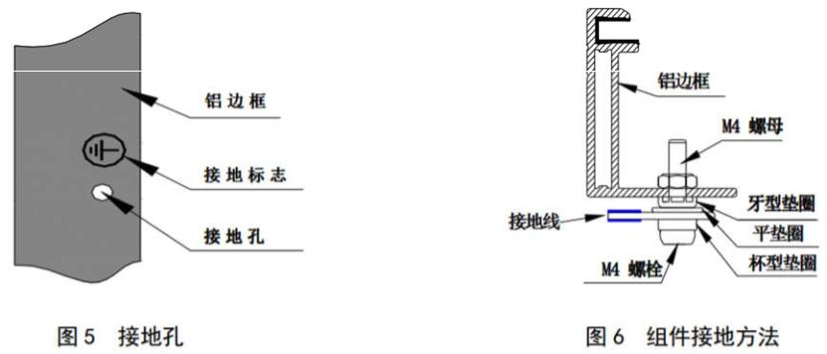
7.5.5 Ground conductors must be connected to the ground through a suitable ground electrode. It is recommended to use grounding wire fittings (nose) to connect grounding cables. Weld the grounding cable into the socket of the nose, then insert the M4 screw into the ring of the nose and the hole in the middle of the component frame, and fasten it with the nut. Spring washers should be used to prevent screw loosening leading to poor grounding.
7.5.6 If the components are used in high temperature and humidity environment, it is recommended that the customer configure the inverter with isolation transformer which can be grounded by negative pole (the system voltage polarity configuration shown in Figure 7).
7.5.7 Our components can be grounded by a third-party grounding device, but the grounding must be reliable and proven. The grounding device is operated according to the requirements of the manufacturer.
8 Maintenance
Components need to be inspected and maintained regularly, especially during warranty period. In order to ensure the best performance of components, the following maintenance measures are recommended.
8.1 Clean
When a component works, there must be no environmental factors that cast shadows on the component and block some or all of the components.

For example: other components, component system brackets, plants, soil or a large amount of dust, which will lead to a significant reduction in output power and may cause hot spots, so it is necessary to regularly clean the glass surface of components. The following points should be noted when cleaning components:
A) Frequency of cleaning components depends on the speed of dirt accumulation. Rainwater normally cleans the surface of components, but soft sponges or rags (dry or clean water) are still needed regularly to clean components In any case, rough surface materials should not be used to clean components, and acid-base detergents should not be used to remove dirt..

B) Avoid local heavy pressure components when cleaning components, which will lead to component glass deformation, damage the battery, and reduce the service life of components.

C) Remove the snow on the components in time to avoid the damage caused by the long-term accumulation of snow and the melting and freezing of snow.
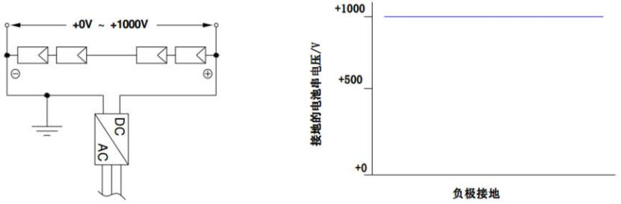
D) Avoid puncturing the back membrane when cleaning the back of the assembly.

E) It is recommended to clean the components in the morning or evening when the light is not strong and the temperature of the components is low, especially in areas with higher temperatures.

F) Do not attempt to clean components with glass breakage or bare wires, which may be in danger of electric shock.
It is recommended that a preventive check-up be conducted every six months, with the following items:

A) Check whether the sealant at the junction box is cracked or cracked;

B) Check the tightness of the connector interface and whether it is loose, melted, deformed, or corroded and aged;

C) Check whether the cable connection is firm and the grounding of the components is good.

When abnormal components are found, please consult professional maintenance personnel. If maintenance is needed, professional maintenance personnel should be responsible for it. When repairing components, cover the surface of components with opaque materials to prevent electric shock. Exposure to sunlight will cause high voltage.
Note:
1. If you find any problems in maintenance, please feedback to the professional maintenance personnel for confirmation;
2. If you use maintenance measures not included in this manual, please consult the local distributor for professional support.
9 Disclaimer
9.1 As the conditions and methods for the use of this manual and the installation, operation, use and maintenance of its components are beyond our control, we shall not be liable for any loss, damage or cost caused by installation, operation, use or maintenance.

9.2 Our company is not liable for product damage caused by defects in installation or power generation system design.

9.3 Our company is not liable for any infringement of patents and third party rights that may result from the use of components. Customers are not authorized to use any patents or patent rights for the use of our components, whether explicit or implicit.

9.4 Our company does not provide any quality assurance when customers fail to operate the installation components according to the requirements listed in this manual.

9.5 The information in this manual is based on our reliable knowledge and experience, but it does not constitute any guarantee, express or implied, including but not limited to the above information and suggestions.

8.3 Inspection of Cables and Connectors
Please carefully check whether there are any appearance defects in the components. Focus on the following items:

A) Check whether the component glass is damaged;

B) Check whether the front of the assembly is covered by obstacles or foreign bodies;

C)Check whether the back plate of the component has burning heat, drum of the back membrane, burn-through marks, etc.

D)Check whether the main grid wire of the battery is corroded or not, and whether there are delamination and bubbles in the package material.

E)Check bolt tightness and electrical wiring condition at installation connection between components and brackets.
8.2 Appearance inspection of components

9.6 We reserve the right to modify this installation manual, component specifications, nameplate or product information without prior notice.

